Module-9

Electrostatics:

It has been known that some materials, such as amber, attract lightweight particles after rubbing. The Greek word for amber electron, was the source of the word 'electricity'. Electrostatic phenomena arise from the forces that electric charges exert on each other.

Coulomb's law
Coulomb's law states that:
'The magnitude of the electrostatic force of attraction or repulsion between two point charges is directly proportional to the product of the magnitudes of charges and inversely proportional to the square of the distance between them.'
The force is along the straight line joining them. If the two charges have the same sign, the electrostatic force between them is repulsive; if they have different signs, the force between them is attractive.
If is the distance (in meters) between two charges, then the force (in newtons) between two point charges and (in coulombs) is:
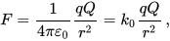

where ε₀ is the vacuum permittivity, or permittivity of free space:^{[1]}
The SI units of ε₀ are equivalently A²s⁴ kg⁻¹m⁻³ or C²N⁻¹m⁻² or F m⁻¹. Coulomb's constant is:
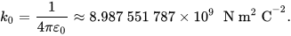
A single prot on has a charge of e, and the electron has a charge of −e, where,
These physical constants (ε₀, k₀, e) are currently defined so that ε₀ and k₀ are exactly defined, and e is a measured quantity.

Electric field

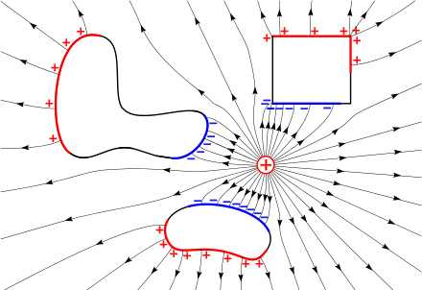

Fig.1 Electrostatic field

The electrostatic field (lines with arrows) of a nearby positive charge (+) causes the mobile charges in conductive objects to separate due to electrostatic induction. Negative charges (blue) are attracted and move to the surface of the object facing the external charge. Positive charges (red) are repelled and move to the surface facing away. These induced surface charges are exactly the right size and shape so their opposing electric field cancels the electric field of the external charge throughout the interior of the metal. Therefore, the electrostatic field everywhere inside a conductive object is zero, and the electrostatic potential is constant.
The electric field, , in units of newtons per coulomb or volts per meter, is a vector field that can be defined everywhere, except at the location of point charges (where it diverges to infinity).^{[2]} It is defined as the electrostatic force in newtons on a hypothetical small test charge at the point due to Coulomb's Law, divided by the magnitude of the charge in coulombs
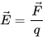
Electric field lines are useful for visualizing the electric field. Field lines begin on positive charge and terminate on negative charge. They are parallel to the direction of the electric field at each point, and the density of these field lines is a measure of the magnitude of the electric field at any given point.

Consider a collection of particles of charge , located at points (called source points), the electric field at is:
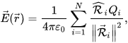
where is the displacement vector from a source point to the field point , and is a unit vector that indicates the direction of the field. For a single point charge at the origin, the magnitude of this electric field is and points away from that charge is positive. The fact that the force (and hence the field) can be calculated by summing over all the contributions due to individual source particles is an example of the superposition principle. The electric field produced by a distribution of charges is given by the volume charge density and can be obtained by converting this sum into a triple integral:
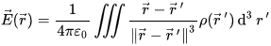

Electrostatic approximation
The validity of the electrostatic approximation rests on the assumption that the electric field is irrotational:
From Faraday's law, this assumption implies the absence or near-absence of time-varying magnetic fields:
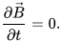
In other words, electrostatics does not require the absence of magnetic fields or electric currents. Rather, if magnetic fields or electric currents do exist, they must not change with time, or in the worst-case, they must change with time only very slowly. In some problems, both electrostatics and magnetostatics may be required for accurate predictions, but the coupling between the two can still be ignored. Electrostatics and magnetostatics can both be seen as Galilean limits for electromagnetism.

Electrostatic potential
As the electric field is irrotational, it is possible to express the electric field as the gradient of a scalar function, , called the electrostatic potential (also known as the voltage). An electric field, , points from regions of high electric potential to regions of low electric potential, expressed mathematically as
The gradient theorem can be used to establish that the electrostatic potential is the amount of work per unit charge required to move a charge from point to point with the following line integral:
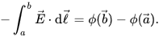
From these equations, we see that the electric potential is constant in any region for which the electric field vanishes (such as occurs inside a conducting object).

Electrostatic energy
A single test particle's potential energy, , can be calculated from a line integral of the work, . We integrate from a point at infinity, and assume a collection of particles of charge , are already situated at the points . This potential energy (in Joules) is:
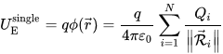
where is the distance of each charge from the test charge q, which situated at the point , and is the electric potential that would be at if the test charge were not present. If only two charges are present, the potential energy is . The total electric potential energy due a collection of N charges is calculating by assembling these particles one at a time:
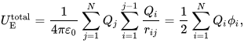
where the following sum from, j = 1 to N, excludes i = j:
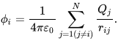
This electric potential, is what would be measured at if the charge were missing. This formula obviously excludes the (infinite) energy that would be required to assemble each point charge from a disperse cloud of charge. The sum over charges can be converted into an integral over charge density using the prescription :
,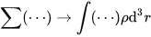
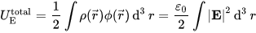
This second expression for electrostatic energy uses the fact that the electric field is the negative gradient of the electric potential, as well as vector calculus identities in a way that resembles integration by parts. These two integrals for electric field energy seem to indicate two mutually exclusive formulas for electrostatic energy density, namely 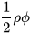and 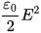; they yield equal values for the total electrostatic energy only if both are integrated over all space.

Permittivity
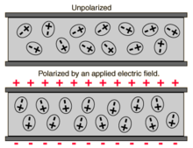
Fig.2 A dielectric medium showing orientation of charged particles creating polarization effects. Such a medium can have a lower ratio of electric flux to charge (more permittivity) than empty space
In electromagnetism, the absolute permittivity, often simply called permittivity and denoted by the Greek letter ε (epsilon), is a measure of the electric polarizability of a dielectric. A material with high permittivity polarizes more in response to an applied electric field than a material with low permittivity, thereby storing more energy in the electric field. In electrostatics, the permittivity plays an important role in determining the capacitance of a capacitor.
In the simplest case, the electric displacement field resulting from an applied electric field is

More generally, the permittivity is a thermodynamic function of state ^{[1]}. It can depend on the frequency, magnitude, and direction of the applied field. The SI unit for permittivity is farad per meter (F/m).
The permittivity is often represented by the relative permittivity which is the ratio of the absolute permittivity and the vacuum permittivity
.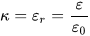
This dimensionless quantity is also often and ambiguously referred to as the permittivity. Another common term encountered for both absolute and relative permittivity is the dielectric constant which has been deprecated in physics and engineering^{[2]} as well as in chemistry.^{[3]}

Relative permittivity
The linear permittivity of a homogeneous material is usually given relative to that of free space, as a relative permittivity ε_{r} (also called dielectric constant, although this term is deprecated and sometimes only refers to the static, zero-frequency relative permittivity). In an anisotropic material, the relative permittivity may be a tensor, causing birefringence. The actual permittivity is then calculated by multiplying the relative permittivity by ε₀:
By definition, a perfect vacuum has a relative permittivity of exactly 1 whereas at STP, air has a relative permittivity of κ_{air} = 1.0006.
Relative permittivity is directly related to electric susceptibility (χ) by
otherwise written as

Capacitance
Capacitance is the ratio of the change in electric charge of a system, to the corresponding change in its electric potential. There are two closely related notions of capacitance: self capacitance and mutual capacitance. Any object that can be electrically charged exhibits self capacitance. A material with a large self capacitance holds more electric charge at a given voltage than one with low capacitance. The notion of mutual capacitance is particularly important for understanding the operations of the capacitor, one of the three elementary linear electronic components (along with resistors and inductors).
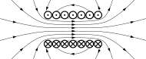
Fig.3 Capacitance
The capacitance is a function only of the geometry of the design (e.g. area of the plates and the distance between them) and the permittivity of the dielectric material between the plates of the capacitor. For many dielectric materials, the permittivity and thus the capacitance, is independent of the potential difference between the conductors and the total charge on them.
The SI unit of capacitance is the farad (symbol: F), named after the English physicist Michael Faraday. A 1 farad capacitor, when charged with 1 coulomb of electrical charge, has a potential difference of 1 volt between its plates.^{[1]} The reciprocal of capacitance is called elastance.
SI unit | farad
Other units | μF, nF, pF
Dimension | M−1 L−2 T4 I2

Capacitors in Series

Capacitors in series means two or more capacitors are connected in a single line i.e positive plate of the one capacitor is connected to the negative plate of the next capacitor. All the capacitors in series have equal charge (Q) and equal charging current (i_{C}).
Consider N- numbers of capacitors are connected in series, then
Q_{T} = Q₁ = Q₂ = Q₃ = ---------- = Q_{N}
I_{C} = I₁ = I₂ = I₃ = --------- = I_{N}

Capacitors in a Series Connection:

The following circuits show the series connection of group of capacitors.
Series connection of N-number of capacitors:​
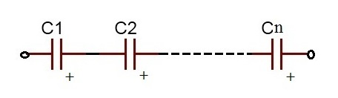
Fig.3 Series connection of capacitors
Series connection of 2 capacitors:​
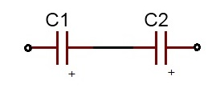
Fig.4 Series connection of 2 capacitors

Capacitance
In this circuit the charge (Q) stored in all capacitors is same because every capacitor has the charge which is flowing from the adjacent capacitor. The voltage drop in all capacitors is different from each other. But the total voltage drop applied between input and output lines of the circuit is equal to the sum of all the individual voltage drops of each capacitor. The equivalent capacitance of the circuit is C_{eq} = Q/V.
Thus,
V_{T} = V₁ + V₂
C_{eq} = Q/V₁ + Q/V₂
1/C_{eq} = (V₁+ V₂)/Q
V_{T} = Q/C_{eq} = Q/C₁ + Q/C₂

Series Capacitors Equation
1/Ceq = 1/C1 + 1/C2 +......... + 1/CN
When the capacitors are in series connection the reciprocal of the equivalent capacitance is equal to the sum of the reciprocals of the individual capacitances of the capacitors in the circuit.
From the figure 2, the reciprocal of equivalent capacitance value of the circuit is equal to the sum of reciprocal capacitances values of two capacitors C₁ and C₂, the expression is given below.
1/C_{eq} = 1/C₁ + 1/C₂

Capacitors in Parallel Circuits

​Capacitors in parallel means two or more capacitors are connected in parallel way, i.e. both of their terminals are connected to each terminal of the other capacitor or capacitors respectively. All the capacitors which are connected in parallel have the same voltage and is equal to the V_{T} applied between the input and output terminals of the circuit. Then, parallel capacitors have a ‘common voltage’ supply across them. i.e. V_{T} = V₁ = V₂ etc.
The equivalent capacitance, C_{eq} of the circuit where the capacitors are connected in parallel is equal to the sum of all the individual capacitances of the capacitors added together. This is because the top plate of each capacitor in the circuit is connected to the top plate of adjacent capacitors. In the same way the bottom plate of each capacitor in the circuit is connected to the bottom plate of adjacent capacitors.
The following circuits show parallel connection between groups of capacitors.
Parallel connection of n number of capacitors:
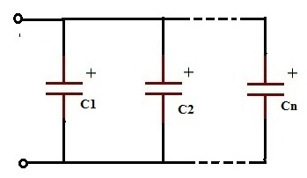
Fig.4 Series connection of n capacitors

Parallel connection of 2 capacitors:
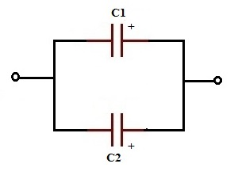
Fig.5 Parallel connection of 2 capacitors
In figure 4 the total charge (Q) across the circuit is divided between the two capacitors, means the charge Q distributes itself between the capacitors connected in parallel. Because the voltage drop across individual capacitors is equal and also it is equal to the total voltage applied to the circuit. But the total charge Q is equal to the sum of all the individual capacitor charges connected in parallel. i.e. From the above figure 4 the two different capacitors C1 and C2 have two different charges Q₁ and Q₂ respectively. Here Q=Q₁+Q₂
Now we see the equivalent capacitance of the capacitors C1 and C2 connected in parallel which shown in the above figure .
We know the formula,
Q=C_{eq} V_{T}
Here, Q = Q₁+Q₂
And V_{T} = V₁ = V₂
C_{eq}=Q/V_{T} = (Q₁+Q₂)/V_{T} = (Q₁/V_{T}) + (Q₂/V_{T})
Parallel Capacitors Equation:

C_{eq =} C₁+C₂+C₃+ ------------ +C_{N}
​The equivalent capacitance of the capacitors which are connected in parallel is equal to the sum of the individual capacitances of the capacitors in the circuit.
From the figure 4, the equivalent capacitance (C_{eq}) value is equal to the sum of both the capacitance values of C₁ and C₂, the expression is shown below.
Ceq = C1+C2

Magnet
A magnet is defined as An object which is capable of producing magnetic field and attracting unlike poles and repelling like poles.

Properties of Magnet
Following are the basic properties of magnet:
- When a magnet is dipped in iron filings, we can observe that the iron filings cling to the end of the magnet as the attraction is maximum at the ends of the magnet. These ends are known as poles of the magnets.
- Magnetic poles always exist in pairs.
- Whenever a magnet is suspended freely in mid-air, it always points towards north-south direction. Pole pointing towards geographic north is known as North pole and the pole pointing towards geographic south is known as South pole.
- Like poles repel while unlike poles attract.
- The magnetic force between the two magnets is greater when the distance between these magnets are lesser.

Mangetic Field
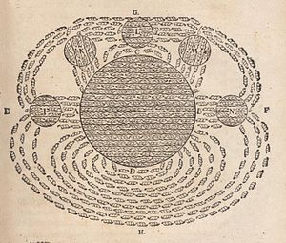
Fig.6 One of the first drawings of a magnetic field, by René Descartes, 1644, showing the Earth attracting lodestones. It illustrated his theory that magnetism was caused by the circulation of tiny helical particles, "threaded parts", through threaded pores in magnets.
Although magnets and magnetism were studied much earlier, the research of magnetic fields began in 1269 when French scholar Petrus Peregrinus de Maricourt mapped out the magnetic field on the surface of a spherical magnet using iron needles. Noting that the resulting field lines crossed at two points he named those points "poles" in analogy to Earth's poles. He also clearly articulated the principle that magnets always have both a north and south pole, no matter how finely one slices them.
Almost three centuries later, William Gilbert of Colchester replicated Petrus Peregrinus's work and was the first to state explicitly that Earth is a magnet. Published in 1600, Gilbert's work, De Magnete, helped to establish magnetism as a science.
In 1750, John Michell stated that magnetic poles attract and repel in accordance with an inverse square law. Charles-Augustin de Coulomb experimentally verified this in 1785 and stated explicitly that the north and south poles cannot be separated. Building on this force between poles, Siméon Denis Poisson (1781–1840) created the first successful model of the magnetic field, which he presented in 1824. In this model, a magnetic H-field is produced by "magnetic poles" and magnetism is due to small pairs of north/south magnetic poles.
Three discoveries in 1820 challenged this foundation of magnetism, though. Hans Christian Ørsted demonstrated that a current-carrying wire is surrounded by a circular magnetic field. Then André-Marie Ampère showed that parallel wires with currents attract one another if the currents are in the same direction and repel if they are in opposite directions. Finally, Jean-Baptiste Biot and Félix Savart announced empirical results about the forces that a current-carrying long, straight wire exerted on a small magnet, determining that the forces were inversely proportional to the perpendicular distance from the wire to the magnet. Laplace later deduced, but did not publish, a law of force based on the differential action of a differential section of the wire,^{[15]} which became known as the Biot–Savart law.
Extending these experiments, Ampère published his own successful model of magnetism in 1825. In it, he showed the equivalence of electrical currents to magnets and proposed that magnetism is due to perpetually flowing loops of current instead of the dipoles of magnetic charge in Poisson's model.] This has the additional benefit of explaining why magnetic charge can not be isolated. Further, Ampère derived both Ampère's force law describing the force between two currents and Ampère's law, which, like the Biot–Savart law, correctly described the magnetic field generated by a steady current. Also in this work, Ampère introduced the term electrodynamics to describe the relationship between electricity and magnetism.
In 1831, Michael Faraday discovered electromagnetic induction when he found that a changing magnetic field generates an encircling electric field. He described this phenomenon in what is known as Faraday's law of induction. Later, Franz Ernst Neumann proved that, for a moving conductor in a magnetic field, induction is a consequence of Ampère's force law.^{[18]} In the process, he introduced the magnetic vector potential, which was later shown to be equivalent to the underlying mechanism proposed by Faraday.
In 1850, Lord Kelvin, then known as William Thomson, distinguished between two magnetic fields now denoted H and B. The former applied to Poisson's model and the latter to Ampère's model and induction.^{[19]} Further, he derived how H and B relate to each other.
The reason the letters H and B are used for the two magnetic fields has been a source of some debate among science historians. Most agree that Kelvin avoided M to prevent confusion with the SI fundamental unit of length, the Metre, abbreviated "m". Others believe the choices were purely random.
Between 1861 and 1865, James Clerk Maxwell developed and published Maxwell's equations, which explained and united all of classical electricity and magnetism. The first set of these equations was published in a paper entitled On Physical Lines of Force in 1861. These equations were valid although incomplete. Maxwell completed his set of equations in his later 1865 paper A Dynamical Theory of the Electromagnetic Field and demonstrated the fact that light is an electromagnetic wave. Heinrich Hertz experimentally confirmed this fact in 1887.
The twentieth century extended electrodynamics to include relativity and quantum mechanics. Albert Einstein, in his paper of 1905 that established relativity, showed that both the electric and magnetic fields are part of the same phenomena viewed from different reference frames. (See moving magnet and conductor problem for details about the thought experiment that eventually helped Albert Einstein to develop special relativity.) Finally, the emergent field of quantum mechanics was merged with electrodynamics to form quantum electrodynamics (QED).

Definitions, units
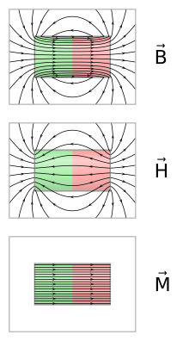
Fig.6 Comparison of B, H and M inside and outside a cylindrical bar magnet.

The B-field
Alternative names for B
- Magnetic flux density
- Magnetic induction
- Magnetic field
The magnetic field can be defined in several equivalent ways based on the effects it has on its environment.
Often the magnetic field is defined by the force it exerts on a moving charged particle. Experiments in electrostatics show that a particle of charge q in an electric field E experiences a force F = qE. Other experiments show that a charged particle experiences a force proportional to its relative velocity to a current-carrying wire. The velocity dependent portion can be separated such that the force on the particle satisfies the Lorentz force law,

Here v is the particle's velocity and × denotes the cross product. The vector B is termed the magnetic field, and it is defined as the vector field necessary to make the Lorentz force law correctly describe the motion of a charged particle. This definition allows the determination of B in the following way^{[23]}
[T]he command, "Measure the direction and magnitude of the vector B at such and such a place," calls for the following operations: Take a particle of known charge q. Measure the force on q at rest, to determine E. Then measure the force on the particle when its velocity is v; repeat with v in some other direction. Now find a B that makes the Lorentz force law fit all these results—that is the magnetic field at the place in question.
Alternatively, the magnetic field can be defined in terms of the torque it produces on a magnetic dipole (see magnetic torque on permanent magnets below).

The H-field
Alternative names for H
- Magnetic field intensity
- Magnetic field strength
- Magnetic field
- Magnetizing field
In addition to B, there is a quantity H, which is often called the magnetic field. In a vacuum, B and H are proportional to each other, with the multiplicative constant depending on the physical units. Inside a material they are different (see H and B inside and outside magnetic materials). The term "magnetic field" is historically reserved for H while using other terms for B. Informally, though, and formally for some recent textbooks mostly in physics, the term 'magnetic field' is used to describe B as well as or in place of H. There are many alternative names for both (see sidebar).

Units:
In SI units, B is measured in teslas (symbol: T) and correspondingly Φ_{B} (magnetic flux) is measured in webers (symbol: Wb) so that a flux density of 1 Wb/m² is 1 tesla. The SI unit of tesla is equivalent to (newton·second)/(coulomb·metre). In Gaussian-cgs units, B is measured in gauss (symbol: G). (The conversion is 1 T = 10000 G.) One nanotesla is equivalent to 1 gamma (symbol: γ). The H-field is measured in amperes per metre (A/m) in SI units, and in oersteds (Oe) in cgs units.

Measurement
The finest precision for a magnetic field measurement was attained by Gravity Probe B at 5 aT (5×10⁻¹⁸ T).
Magnetometers are devices used to measure the local magnetic field. Important classes of magnetometers include using induction magnetometers (or search-coil magnetometers) which measure only varying magnetic fields, rotating coil magnetometers, Hall effect magnetometers, NMR magnetometers, SQUID magnetometers, and fluxgate magnetometers. The magnetic fields of distant astronomical objects are measured through their effects on local charged particles. For instance, electrons spiraling around a field line produce synchrotron radiation that is detectable in radio waves.

Magnetic field lines
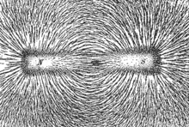
Fig.7 The direction of magnetic field lines represented by iron filings sprinkled on paper placed above a bar magnet.
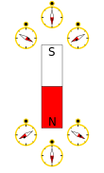
Fig.8 Compass needles point in the direction of the local magnetic field, towards a magnet's south pole and away from its north pole.
Mapping the magnetic field of an object is simple in principle. First, measure the strength and direction of the magnetic field at a large number of locations (or at every point in space). Then, mark each location with an arrow (called a vector) pointing in the direction of the local magnetic field with its magnitude proportional to the strength of the magnetic field.
An alternative method to map the magnetic field is to "connect" the arrows to form magnetic field lines. The direction of the magnetic field at any point is parallel to the direction of nearby field lines, and the local density of field lines can be made proportional to its strength. Magnetic field lines are like streamlines in fluid flow, in that they represent something continuous, and a different resolution would show more or fewer lines.
An advantage of using magnetic field lines as a representation is that many laws of magnetism (and electromagnetism) can be stated completely and concisely using simple concepts such as the "number" of field lines through a surface. These concepts can be quickly "translated" to their mathematical form. For example, the number of field lines through a given surface is the surface integral of the magnetic field.
Various phenomena "display" magnetic field lines as though the field lines were physical phenomena. For example, iron filings placed in a magnetic field form lines that correspond to "field lines". Magnetic field "lines" are also visually displayed in polar auroras, in which plasma particle dipole interactions create visible streaks of light that line up with the local direction of Earth's magnetic field.
Field lines can be used as a qualitative tool to visualize magnetic forces. In ferromagnetic substances like iron and in plasmas, magnetic forces can be understood by imagining that the field lines exert a tension, (like a rubber band) along their length, and a pressure perpendicular to their length on neighbouring field lines. "Unlike" poles of magnets attract because they are linked by many field lines; "like" poles repel because their field lines do not meet, but run parallel, pushing on each other. The rigorous form of this concept is the electromagnetic stress–energy tensor.

Magnetic Flux Density
Magnetic flux density(B) is defined as the force acting per unit current per unit length on a wire placed at right angles to the magnetic field.
- Units of B is Tesla (T) or Kgs −2 A −1
- B is a vector quantity

Magnetic Flux Density Unit:
The CGS and SI unit of magnetic flux density is given in the table below.
Unit of Magnetic Flux Density
SI unit | Tesla (abbreviated as T)
CGS unit | Gauss (abbreviated as G or Gs)

References:
1. “Text book of Physics-I & II” by K.N. Barik, N. Barik and L. K. Das, Kalyani Publisher,2008.
2. sites.google.com
3. en.wikipedia.org
4. www.ukessays.com

Question Bank
1. State and explain Coulombs law of Electrostatics.
2. What is Absolute and Relative Permittivity?
3. Explain Electric Potential and Electric Potential difference.
4. Define Electric Field intensity.
5. Find equivalent capacitance for series connected capacitors.
6. Find equivalent capacitance for parallel connected capacitors.
7. Write down the properties of Magnets.
8. Write and explain Coulombs law of Mangetostatics.
9.Define Magnetic Field intensity and Magnetic Flux density.

